MAY 2014

Welcome all Senior Golfer’s Society members

MEMBERSHIP NEWS
OBITUARIES:
It is with great sadness that we record the passing of Lal Greene on the 28th April 2014.

BIRTHDAYS
There were 24 Birthdays in May 2014. There were three in the eighties and three in the nineties.

Birthdays in the Eighties:
Vernon Webber turned 86 on May 1st. He was born in 1928.
David Machen turned 80 on May 20th. He was born in 1934.
Terry Field turned 83 on May 20th. He was born in 1931.

Birthdays in the Nineties:
Bruce Lobban turned 90 on May 12th. He was born in 1924. Well done Bruce.
Andre Maitre turned 92 on May 19th. He was born in 1922. Well done Andre.
Hugh Hein turned 90 on May 29th. He was born in 1924. Well done Hugh.

We wish all of the birthday boys a very Happy Birthday.

COMPETITION RESULTS

REPORT BACK ON THE 75TH NATIONAL TOURNAMENT HELD IN DURBAN

It was third time lucky with the weather for the SGUSA National Tournament held in Durban from the 5th to the 9th May. We had almost perfect weather for the four days of the tournament – the wind did blow a bit on the Tuesday when the Alliance event was played. Both the Royal Durban and Durban Country Club courses were in superb condition while the organisation and programme arrangements were top class. Jelli Jelliman and his organising committee deserve a standing ovation for arranging a superb tournament. The several letters of congratulation received from our sister Societies and individuals bear witness to the success of the tournament.

There are five major trophies awarded for the SGUSA Annual National Tournament:

The Carlton Levick Trophy for the Best 36 Holes Individual Stroke Play.
The Leslie Satchwell Trophy for the Best Net Stableford Score over 36 Holes.
The Pinehurst Foursomes Trophy presented by the UK Society to SGUSA in 1951
The Admiral Benson Putter for the best Stableford score over 18 holes for those over 80 years old
The Methuselah Trophy for the best Net Stableford score over 36 holes for those over 75 years old

We are proud to announce that members of our Society won all five trophies listed above.
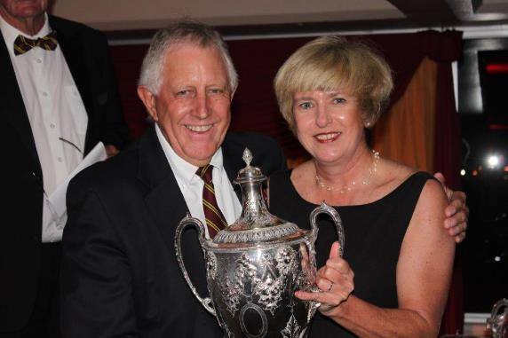
Congratulations to Alistair Forbes on once again winning the Carlton Levick Trophy for the leading gross score. Alistair shot 75 and 77 to tie Mike Seligmann, but he won on a count out, which as is our custom was decided on age – the oldest being the winner.
Blaize McIntosh was four strokes back scoring 78 and 78.

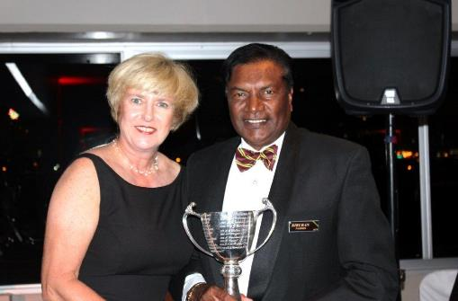

Kiruban Naidoo won the Leslie Satchwell Trophy with a Best Net Stableford score of 80 points over 36 holes. He was closely followed by Mike Seligmannn who was runner up with 78 points.

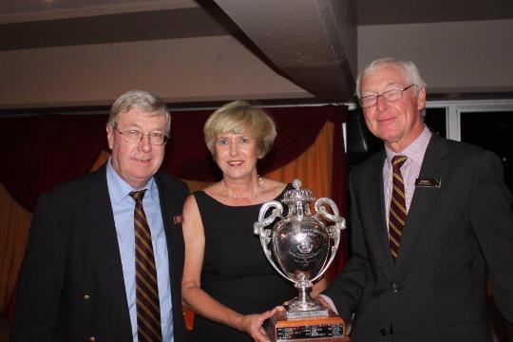

The Pinehurst Foursomes Trophy champions Neill Edwards and Mike Mun-Gavin were in good shape to win the trophy when they scored 44 Better Ball Stableford Points on the Royal Durban course.

Dan Sterling and Geoff Henebrey were the winners at the Durban Country Club course with 41 Better Ball Stableford Points.
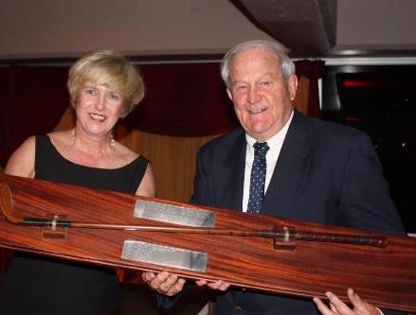

Barry Kramer carded a score of 38 Stableford Points to win the Admiral Benson Putter for the best Stableford score over 18 holes.

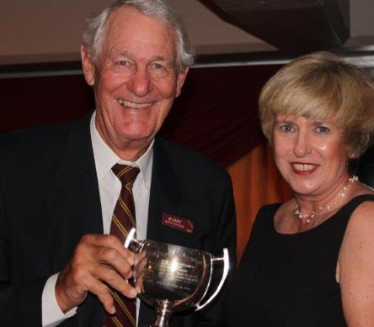

Barry Beningfield carded a score of 75 Stableford Points to win the Methuselah Trophy for the best Stableford score over 36 holes in the age category 75 years and older.

Other notable achievements by our members were as follows:

CLASS B – Net - Age 60 to 64
Winner: Frank Agg 76 Points
Runner Up: Neil MacNeillie 72 Points

CLASS C - Net - Age 65 to 69
Winner: Rob Little 76 Points
Runner Up: Rae Stewart 75 Points

CLASS D - Gross - Age 70 to 74
Winner: Blaize McIntosh 80 Points

CLASS E – Net - Age 75 and over
Winner: Barry Beningfield 75 Points

CLASS E – Gross - Age 75 and over
Winner: Bran Stokoe 53 Points

KZN did exceptionally well in the team event, taking the first four places. KZN had 7 teams in the top 10.

Team Event Over 36 Holes Stableford
Winners: KZN – Brian Stokoe, Chris Good, Neill Edwards
and Rae Stewart 222 Points

Runner up: KZN - Kiruban Naidoo, Bob Rickards, Jonathan Hallowes
and Roger Mentzel 221 Points

Third: KZN – Pregi Moodley, Rob Little, John Allan
and Malcolm King 219 Points

Fourth: KZN – Mike Seligmann, Alistair Forbes, Blaize McIntosh
and Mike Mun-Gavin 218 Points

Well done to all our members who featured in the results - you did KZN proud!!

A full list of all the results are available on the website and from Dan and Colleen at the Seniors Office.

Next year’s National Tournament will be held in Bloemfontein from 19 April to 24 April 2015 and members may wish to diarise these dates.

Tuesday 20 May 2014 – Inland versus Coastal – Lal Greene Trophy at Gowrie Farm Golf Club
We had a full field of 52 players for this annual Coastal versus Inland challenge. The reward for the winning team is the Lal Greene Trophy. Unfortunately, Lal Greene passed away shortly before this event, but the trophy is a reminder of his contribution to our Society. On a perfect day for golf, on a beautifully presented golf course, the Coastal Team were the victors for the fourth time.

Results of the day were:
The Lal Greene Trophy was won by the Coastal Team

Team Event:
1st Coastal 498 Points
2nd Inland 459 Points

Individual:
1st John Allan and Blaize McIntosh 47 Points

2nd David Suddards and John Terry-Lloyd 44 Points

3rd Malcolm Hughes and Ian McIntosh 43 Points

4th David Cousens and Jelli Jelliman (51 027 Days Old) (By 1 417 Days) 42 Points

On a Count Out From:
5th Peter Bailey and Arrol Paterson (49 610 Days Old) 42 Points

Our sincere apologies to David Cousens and Jelli Jelliman for the error in omitting them at prize giving.

All our competitions are kindly sponsored by:

SANLAM PRIVATE INVESTMENTS

GRANT’S WHISKY GRINDROD ASSET MANAGEMENT
SA BREWERIES GOWRIE FARM RAY RAMANDH

PLEASE SUPPORT OUR SPONSORS.

FORTHCOMING FIXTURES

Tuesday 10 June 2014 – Better Ball Bonus Bogey at Selborne Country Club
Entry Form on the website under “Fixtures/Entries”. First tee off time 10h30.

This event is sponsored by Trevor Dunsdon and Richard Evans and the six sponsors detailed below.

Entries close on Friday 30 May 2014.

Thursday 26 June 2014 and Friday 27 June 2014 – Alliance Stableford/Better Ball Stableford at Southbroom Country Club
Entry Forms on the website under “Fixtures”. Tee off times are 10h30 on the Thursday and 08h01 on the Friday.

The Southbroom fixture will take the form of an Alliance Stableford (two scores to count) on Thursday afternoon 26 June and a Better Ball Stableford on Friday morning 27June. Members can travel down to Southbroom on the Thursday morning; play golf that afternoon, followed by a braai at the Club in the evening.

We will then stay the night in Southbroom and tee up on Friday morning for the Alliance. This will be followed by prize giving, returning home in the afternoon. Members are asked to arrange their own accommodation for their overnight stay.

It goes without saying that wives/partners are welcome and should any of the ladies wish to play golf on either of the two days or both days, will you please enter via the website.

There will be a Starting Sheet for all the above events. As has been our custom in the past, the Starting Sheet will be e-mailed to those members who have e-mail and will also be e-mailed to the usual clubs where they will appear on the Notice Boards.

This event is sponsored by Ant Hacker, Tim Hooper, Peter Ledger, Andre Schoeman, Tim Hitchins and the five sponsors detailed below.

Entries close on Friday 13 June 2014.

Tuesday 15 July 2014 – Better Ball Stableford Waiting List Game at Royal Durban Golf Club
Entry Form on the website under “Fixtures”. Tee off time are 11h00.

This event is sponsored by Brian Attwood-Smith, David Attwood-Smith, Noel Attwood-Smith and the six sponsors detailed below.

Entries close Friday 4 July 2014.

The six sponsors for all the above events are Sanlam Private Investments, for golf ball prizes, Grants Whisky for nearest the pin on two short holes and attendance prizes, South African Breweries for Castle Lite Beer, Gowrie Farm for one night’s accommodation for 8 people at The Folie, Grindrod Asset Management for golf balls for 2’s and Ray Ramandh for lucky draw prize of a month’s car wash vouchers.

There will be a Starting Sheets for all the above events. We are encouraging members to check their tee off times on the new KZN website. Don’t forget the website is accessed by entering www.kznseniors.com into your computer search engine (Google) and select the first option which is “Senior Golfers’ Society KZN – Home”. This will open the website. It is our intention to start phasing out e-mailing the Alphabetical Lists and Starting Sheets for all our games. For the time being we will however continue to e-mail you Alphabetical Lists and Starting Sheets.

NEWS ITEMS

75th National Tournament – Durban
The following e-mail of congratulations was received from John Hare, Chairman of Mancom:

“Hi Jelli,
Having just arrived home after a spell at Coffee Bay following Nationals I now have the opportunity to thank you and your committee, ably supported by the KZN team and all who assisted, marshalled, transported, helped the ladies and the thousand and one other tasks,
KZN always does the National entrants proud with exceptionally good planning and this year was no exception!
Blessed by good weather, everyone had a great time! I'm only sorry Bill Dixon didn't live to see how great this tournament was, his would no doubt have come a close second had he had the right weather!
Please thank all concerned, we will post mortem it and let you have any comments ASAP but rest assured all Societies and members owe all of you sincere thanks for a great week in Durban!!
Best wishes
John Hare
Chairman
Mancom”

SECRETARIAT - Change of email address and IT improvements
We have completed an upgrade of our office IT equipment that has resulted in several changes. They are:

- Our new email address is:
office@seniorgolf.co.za

We will continue to receive emails if addressed to seniorg@telkomsa.net but we would appreciate it if all members can update their address books to reflect our new email address.

2. We no longer have a telephone answering machine. If the office line 031 309 2206 is not answered the line will eventually connect with our Fax line. So if you wish to send a Fax please wait for the Fax connection.

We sincerely hope that our new email, website and Fax facilities will ensure that we can easily communicate with all our members.

Sponsored Lucky Draw Prize:
We are fortunate to have another sponsored lucky draw prize which will be awarded during prize giving after each fixture. Ray Ramandh is sponsoring one month’s car wash vouchers for each game at the Whynotte Service Station Car Wash at 13-15 Umhlanga Rocks Drive, Durban North.

The prize is 4 car wash vouchers for each game, which will include:

3 Wash and Wipe tickets
1 full wash with Vacuum and silicone to the tyres

The above tickets will be valid for one month, from the date of the game.

The tickets can be used once a week or at any time to the convenience of the winner, but the tickets will expire the following month on the same date as the date of the previous month that the winner received the tickets.

Rules Interpretation
We received the following e-mail from Peter Walker who was recently involved in a very interesting Rules Interpretation incident which we are certain will be of interest to all our members.

During the recent, most successful, SGUSA National Tournament I was in a four ball alliance where each one of us were from a different Society. An incident occurred that involved touching the sand in a bunker. The interesting thing about this is the confusion that existed in interpreting the rule and it may be of interest to other Senior golfers to go over the issue.

The situation was that the player was in a fairway bunker that required a long hit to get near the green. In doing so, instead of a steep backswing used in greenside bunkers, the player took a long sweeping backswing and just touched a raised lump of sand in the course of the stroke.

Although no-one saw this, the player was filled with remorse at the thought of keeping this secret and confessed to his fellow competitors in the forlorn hope that they would say it’s all right. Surprisingly the opinion was expressed that they didn’t think that there was a penalty since this happened in the process of making a stroke – and anyway you should hit the sand before the ball in the process of trying to get out of the bunker. The player, however, in seeking redemption penalized himself and carried on playing, full of righteousness.

But what do the Rules say? Rule 13-4 Ball in hazard; Prohibited Actions:

Except as provided in the Rules, before making a stroke at a ball that is in a hazard (whether a bunker or a water hazard) …….. the player must not:
a. Test the condition of the hazard….
b. Touch the ground in the hazard or water in the water hazard with his hand or a club; or
c. Touch or move a loose impediment lying in or touching the hazard.

It is noted that there are some exceptions, briefly as follows:
1. If touching was as a result of preventing falling, in removing an obstruction or in marking the position of the ball, or placing clubs in a hazard.
2. At any time a player may smooth sand in a bunker provided this is for the sole purpose of caring for the course.

Peter Dobereiner in his book “Golf Rules Explained” has this to say:
So what happens if you brush the sand with your clubhead on the backswing? And is that the same if you touch the grass on the banking? The answer is that touching the grass (or stone or wood banking) involves no infringement since it is not in the hazard. Touching the sand on your backswing is an offence since a “stroke” is defined as forward motion of the club and you have thus touched the ground before making a stroke.

The general penalty applies – two shots penalty or loss of hole in match play.

Comment – with all the permitted ways that you may touch the sand it seems particularly harsh that you are severely punished when you touch during your swing with no possible advantage. Is the law an ass?

PH Walker 12 May 2014

Dates to remember in 2014
June 12-15. US Open - the No. 2 Course of the Pinehurst Resort in Pinehurst, North Carolina.
July 17-20. The Open Championship – Royal Liverpool (Hoylake)
August 7-10. US PGA – Valhalla Golf Club in Louisville, Ky., for the first time in 14 years

PARTING SHOT
60th High School Reunion
He was a widower and she a widow. They had known each other for a number of years, being high school classmates, and having attended class reunions in the past without fail.

This 60th anniversary of their school, the widower and the widow made a foursome with two other singles. They had a wonderful evening, their spirits high. The widower throwing admiring glances across the table. The widow smiling coyly back at him.

Finally, he picked up courage to ask her, "Will you marry me?" After about ten seconds of careful consideration, she answered, "Yes..........yes I will!"

The evening ended on a happy note for the widower. But the next morning he was troubled. Did she say Yes or did she say No? He couldn't remember. Try as he would, he just could not recall. He went over the conversation of the previous evening, but his mind was blank. He remembered asking the question, but for the life of him he could not recall her response. With fear and trepidation, he picked up the phone and called her.

First, he explained that he couldn't remember as well as he used to. Then he reviewed the past evening. As he gained more courage, he inquired of her, "When I asked if you would marry me, did you say Yes or did you say No?”

"Why you silly man, I said Yes. Yes I will! And I meant it with all my heart."

The widower was delighted. He felt his heart skip a beat. Then she continued. "And I am so glad you called because I couldn't remember who asked me!”

CREDITS

THE SOCIETY IS INDEBTED TO CUT PAPERS (PTY) LIMITED FOR PRINTING AND SUPPLYING THE PAPER FOR OUR NEWSLETTER

